Name: Jack

Student ID: D1166506

Flow Chart:

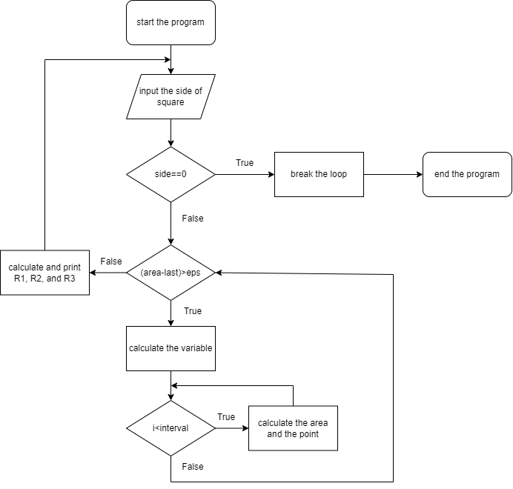

Pseudo code:

1. loop (forever)
2. {
3. initialize variables
4. input (side)
5. if (side==0) break
6. loop (diff>eps)
7. {
8. calculate the area
9. }
10. calculate for R1, R2, and R3
11. print R1, R2, and R3
12. }

        To deal with this assignment, at first, I used the proof in the document to get the equation of R1, R2, and R3.

        Next, I started programming and initialized a lot of variables that would be used later. Then, print the sentence and input the side of the square a. If the variable a is not equal to 0, then break the loop.

        To compute the area, I used the while loop with the condition that the difference between area and last must be greater than 1e-6, which is epsilon equivalently. Then, compute the variable first, and then the area using the Riemann sum.If the area is calculated well and fits the condition of the loop, calculate the variables R1, R2, and R3.

        Eventually, while all the calculating is done, print the variables R1, R2, and R3 as required.